LAB 01

Q1. Write a simple poem and represent it as a web page. Give a title for the poem.

Make rhyming words in the poem as bold.

<!DOCTYPE html>

<html>

<head>

<title>Poem</title>

</head>

<body>

<div style=>

<h1>Twinkle Twinkle Little Star</h1>

<p>

twinkle twinkle little <b>star</b><br>

how i wonder what you <b>are</b><br>

up above the world so <b>high</b><br>

like a diamond in the <b>sky</b><br>

</p>

</div>

</body>

</html>

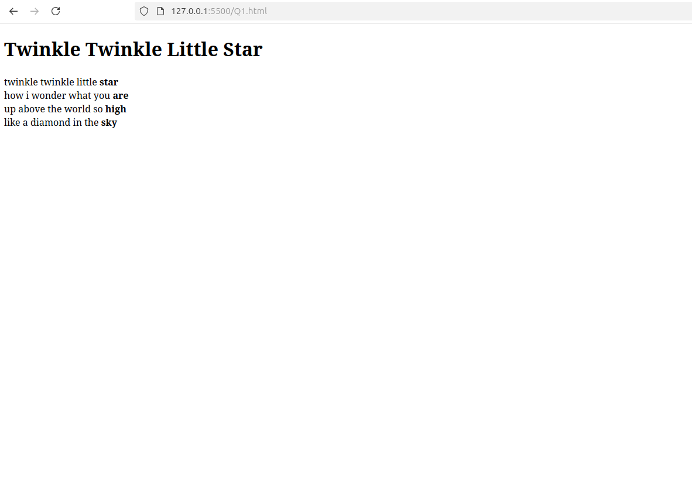  
  
Q2. Assume you have brought a new car. Write down the list of additional

accessories you need for the car as an unordered list in HTML. Also, list the

travel plans on the car as an ordered list.

<!DOCTYPE html>

<html>

<head>

<title>

CAR

</title>

</head>

<body>

<h2>Car Accessories</h2>

<ul>

<li>Lighting</li>

<li>Dash Camera</li>

<li>GPS</li>

<li>Phone Mount</li>

<li>Seat Cover</li>

<li>Air Purifier</li>

</ul>

<h2>Travel Plans</h2>

<ol>

<li>Mumbai</li>

<li>Delhi</li>

<li>Kolkata</li>

<li>Chennai</li>

<li>Sikkim</li>

<li>Bangalore</li>

</ol>

</body>

</html>

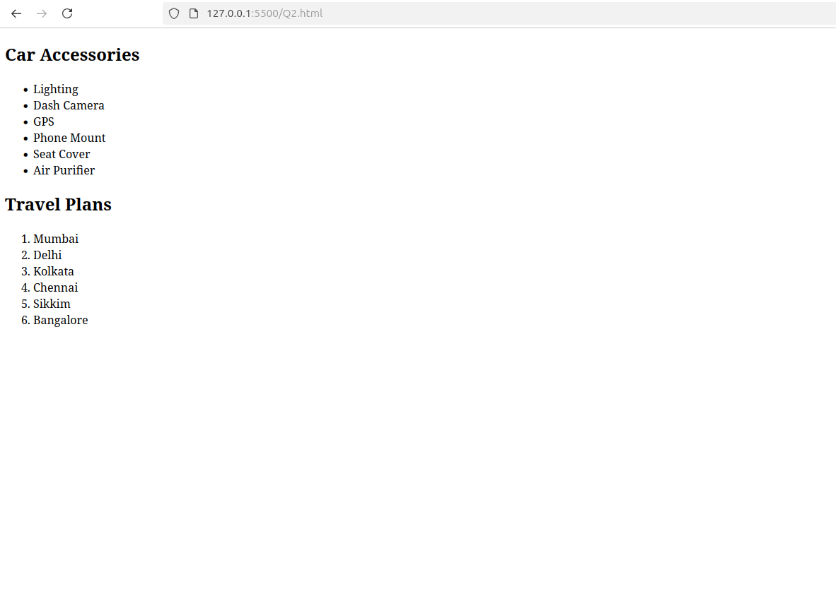

Q3. Complete the following website name “Share your Winter Vacation Videos”.

The required video files are located inside the compressed folder “Week 1

Assignment Files/Media/”.

<!DOCTYPE html>

<html>

<head>

<title>Winter Vacation</title>

</head>

<body style="height: 100vh; background-image: linear-gradient(to bottom, rgb(73, 159, 230), rgb(255, 255, 255));">

<div style="margin: 0; font-size: 3rem; width: 100vw; background-color: cornflowerblue; color: white; font-family: 'Lucida Sans'; ">

Share Your Travel

</div>

<div style="display: flex; flex-direction: column; margin: 1rem; flex-wrap:wrap;">

<div style="font-style: italic; color: white; font-size: 2rem; font-family: 'Lucida Sans';">HTML Videos</div>

<div style="display: flex; justify-content: space-around; gap: 1rem;">

<div>

<video width="500" height="300" controls>

<source src="video.mp4" type="video/mp4">

Your browser does not support the video tag.

</video>

</div>

<div>

<video width="500" height="300" controls>

<source src="video.mp4" type="video/mp4">

Your browser does not support the video tag.

</video>

</div>

<div>

<video width="500" height="300" controls>

<source src="video.mp4" type="video/mp4">

Your browser does not support the video tag.

</video>

</div>

</div>

</div>

</body>

</html>

